1) Create one vpc in N.virginia region

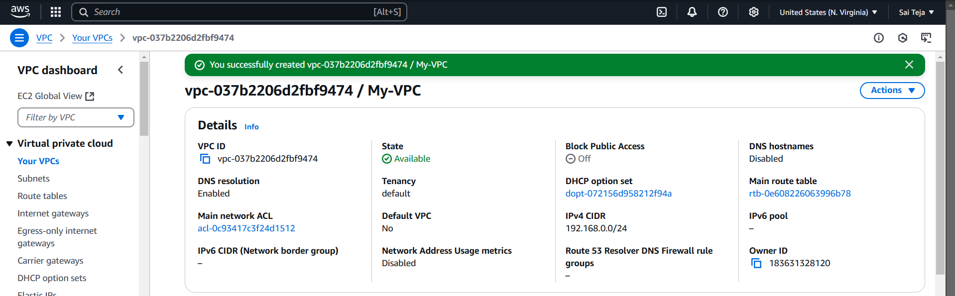

2) Create two subnets. One Public subnet and one private subnet.

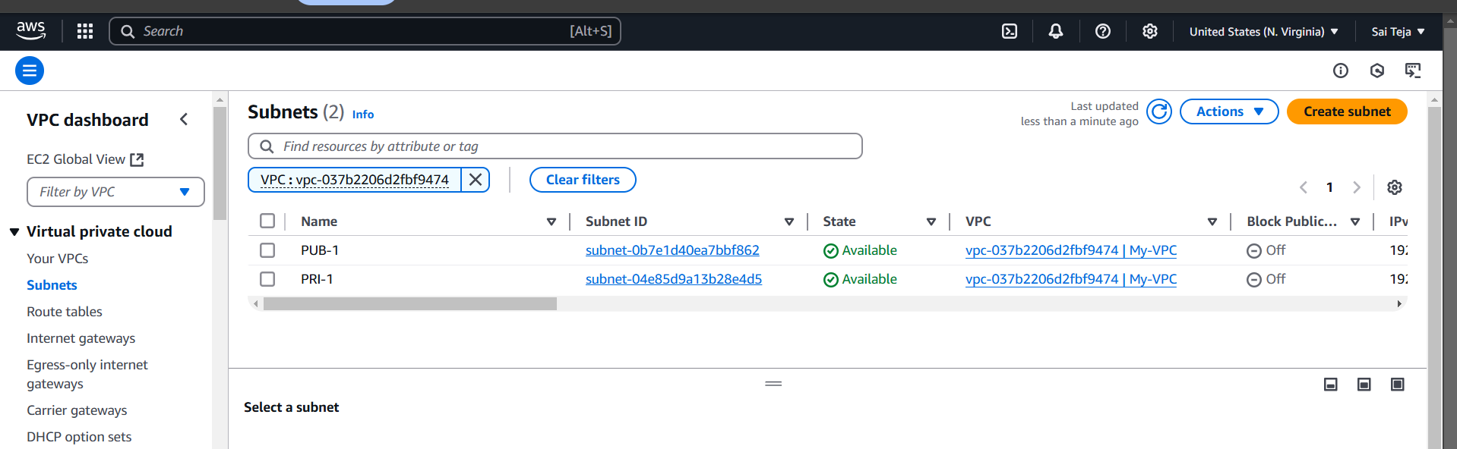

3) Provide the IGW to the vpc.

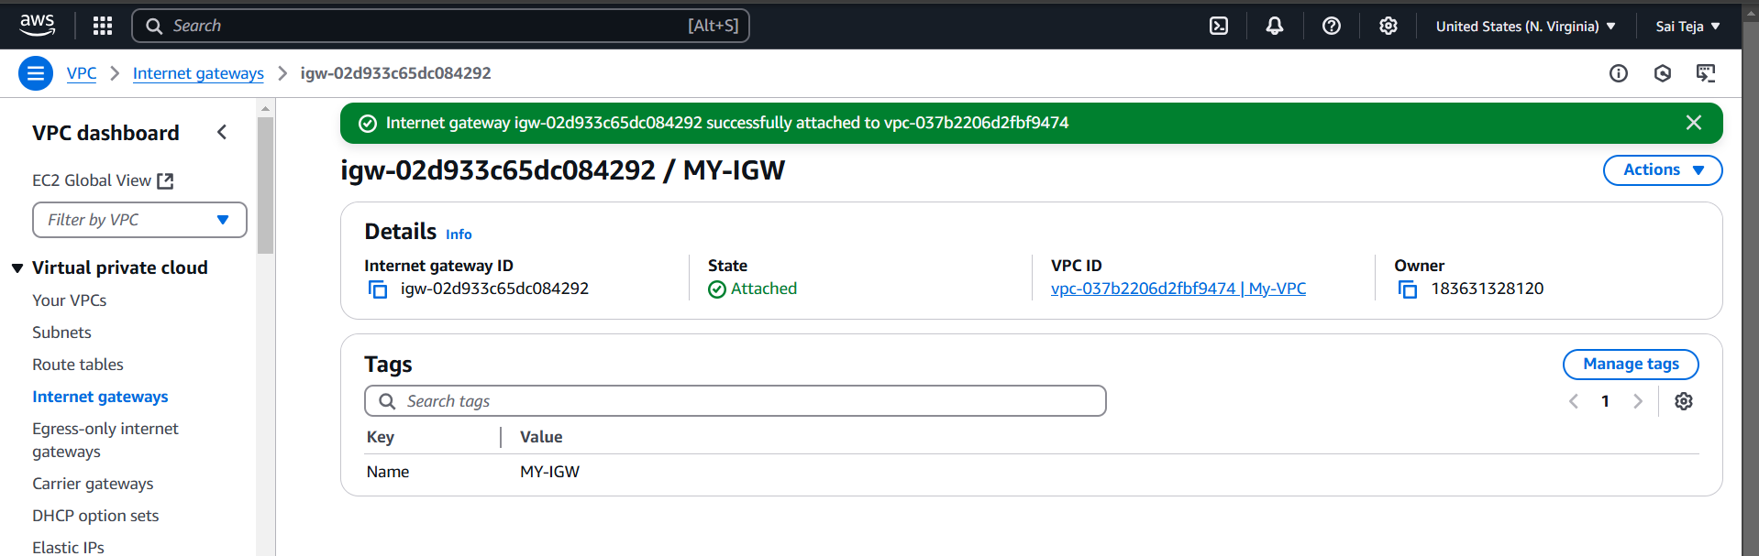

4) Create One public RT and one private RT.

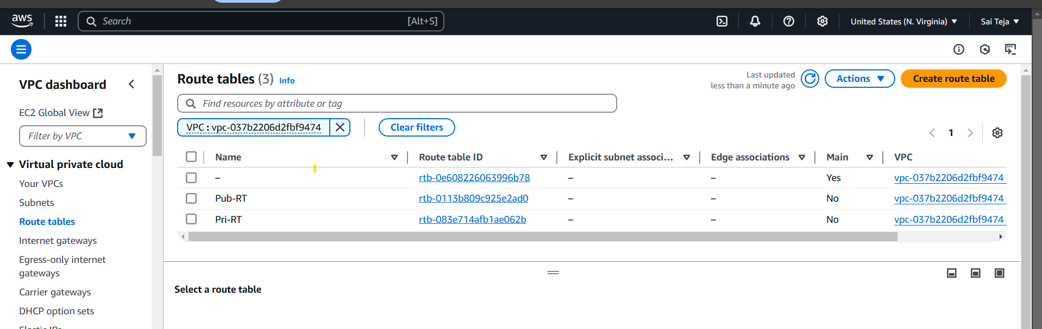

5) Deploy NAT gateway on public subnet and attach the NAT gatewat to private subnet

---- created NAT gateway on public subnet

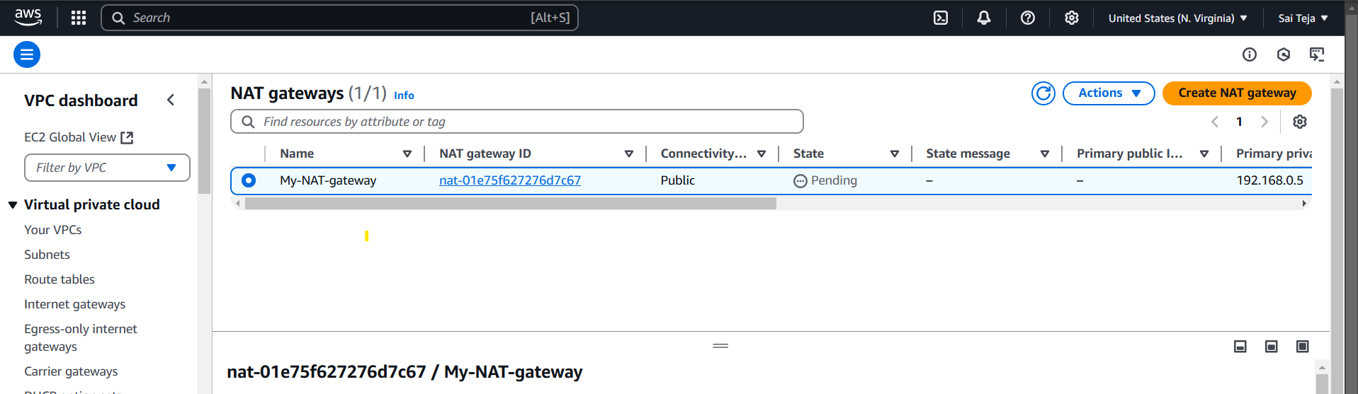

---- attached Nat gateway to pri subnet

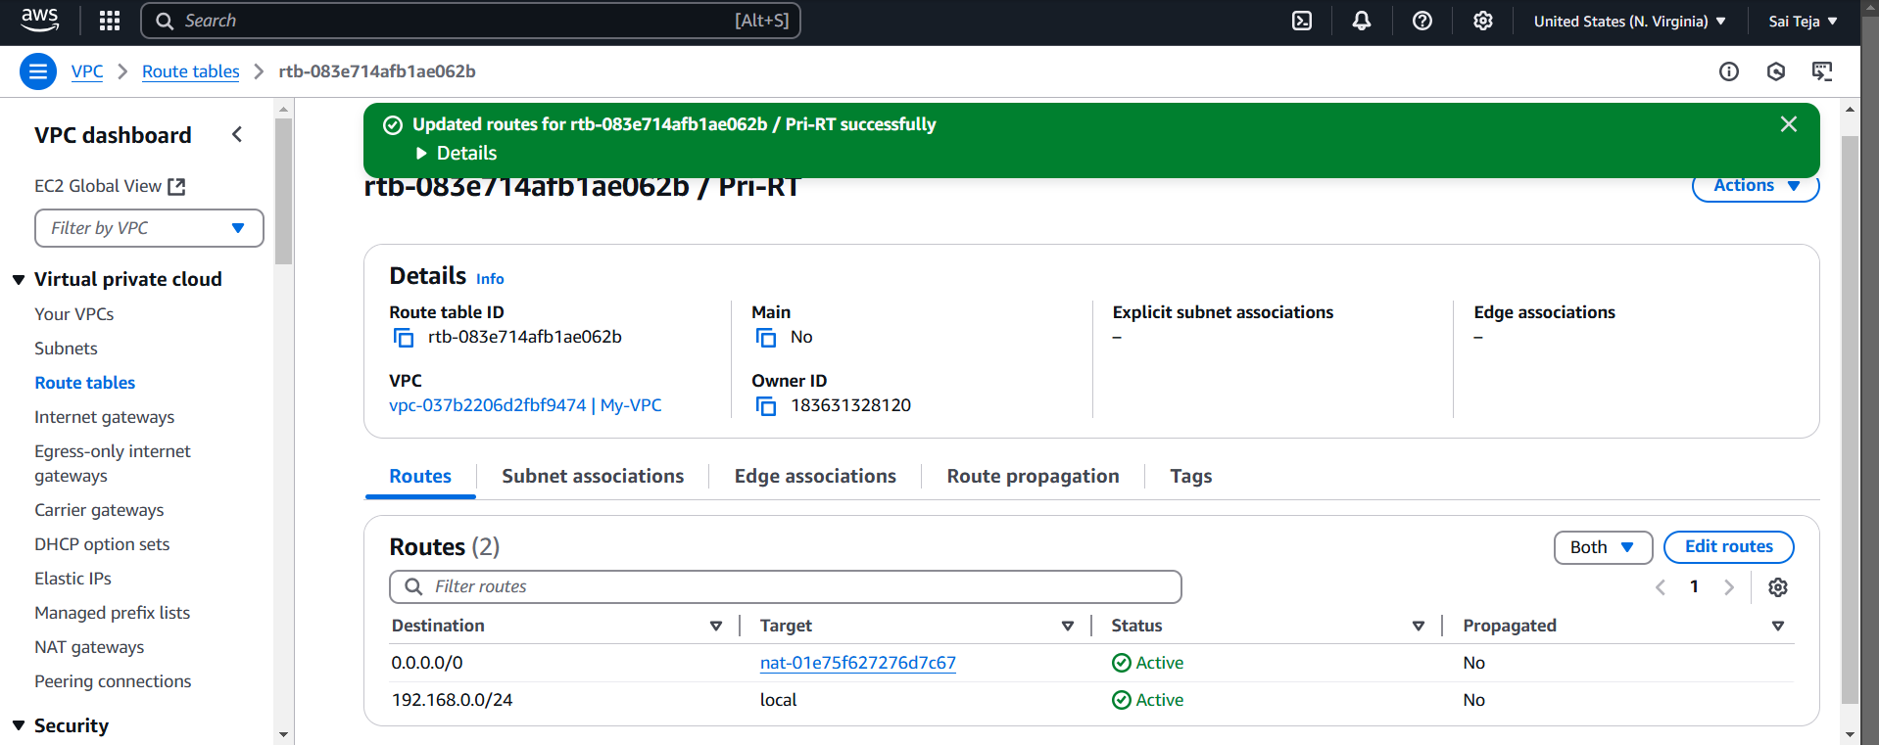

6) Create Two instances,one in public subnet and one in private subnet.

----- created 2 instances , 1 in pub-subnet and 1 in pri-subnet

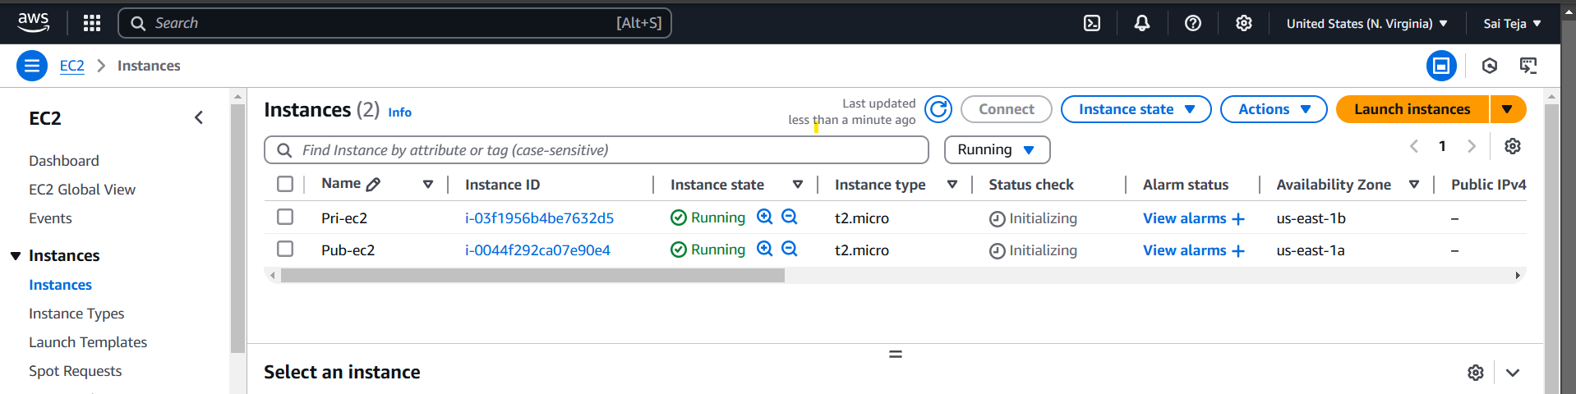

7) Deploy Apache server on both the ec2 instances with sample index.html file.

---- installed httpd in pub-ec2

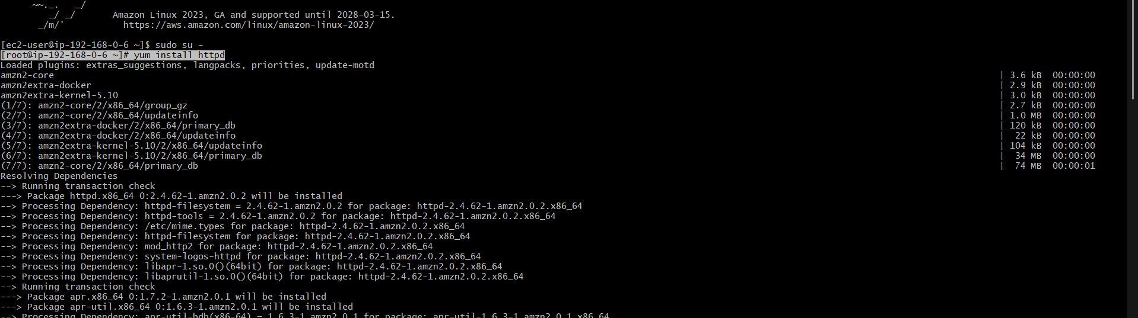

--- the check if it is running or not , if not running then start the httpd

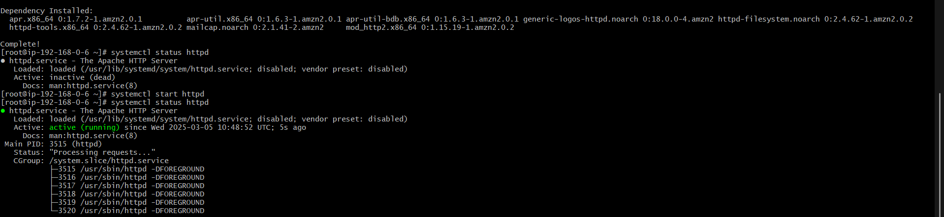

------ I want to deploy my open page the go to the location var/www/html and create one index.html file

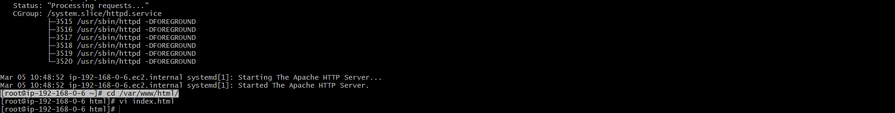

----- then we can check in browser , your new index.html is deployed

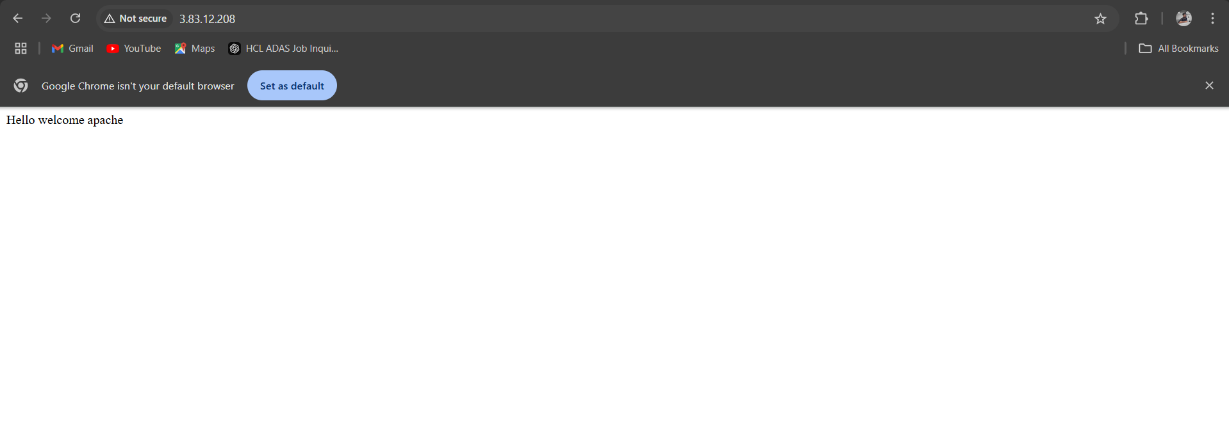

--- cat the pri-ec2 pem key and copy the pem key

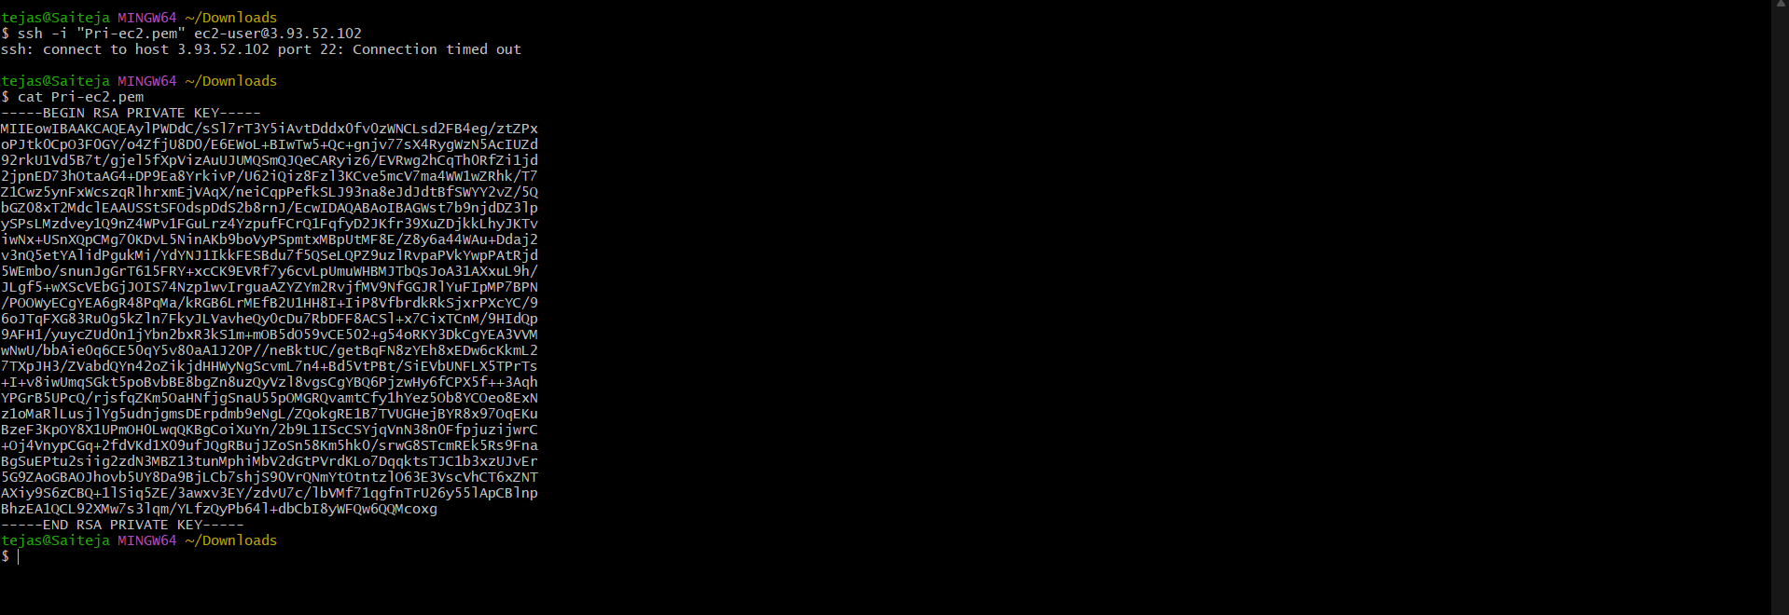

--- go to the pub-ec2 and paste the create new file with.pem and paste the pri-ec2 pem key the provide the permission and login using Pri id of pri-ec2 using ssh -1

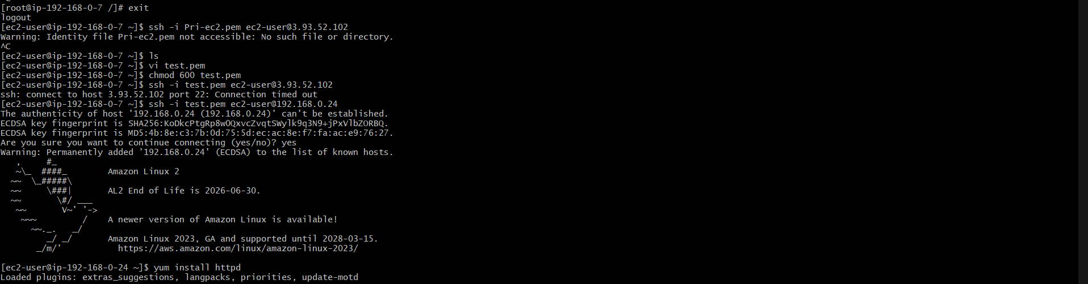

Install httpd and create one index.html file check the deployed with using curl

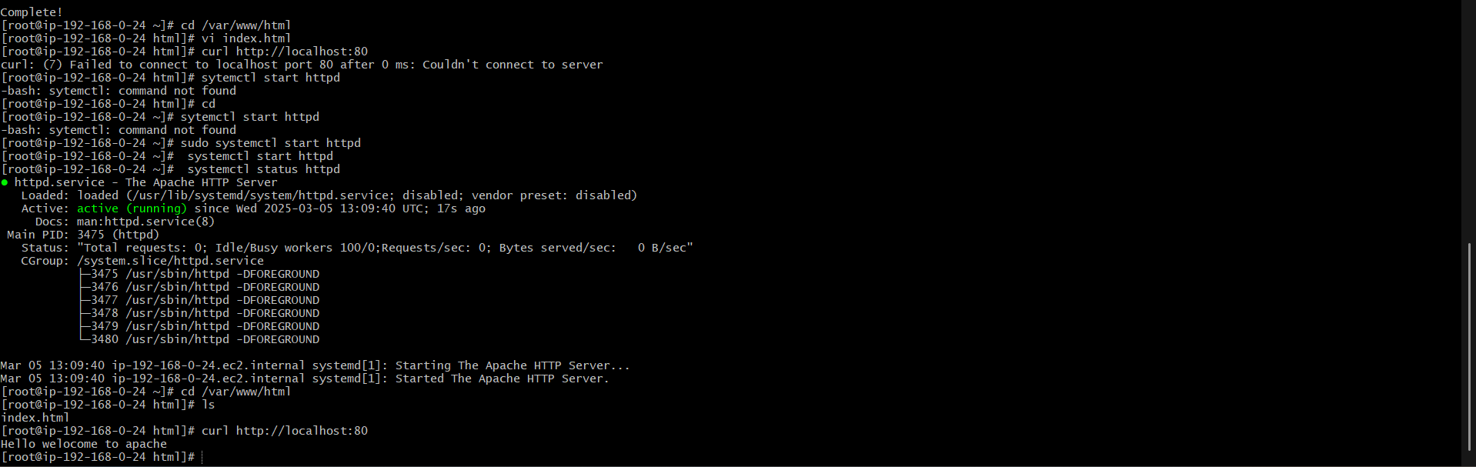

11) Create Monitoring Dashboards to monitor cpu utilization and to monitor apache service.

------- install apache , set the status in running  
------- create one script (monitoring.bash) and provide permissions   
-------- provide crontab as well to run the script every 1 min

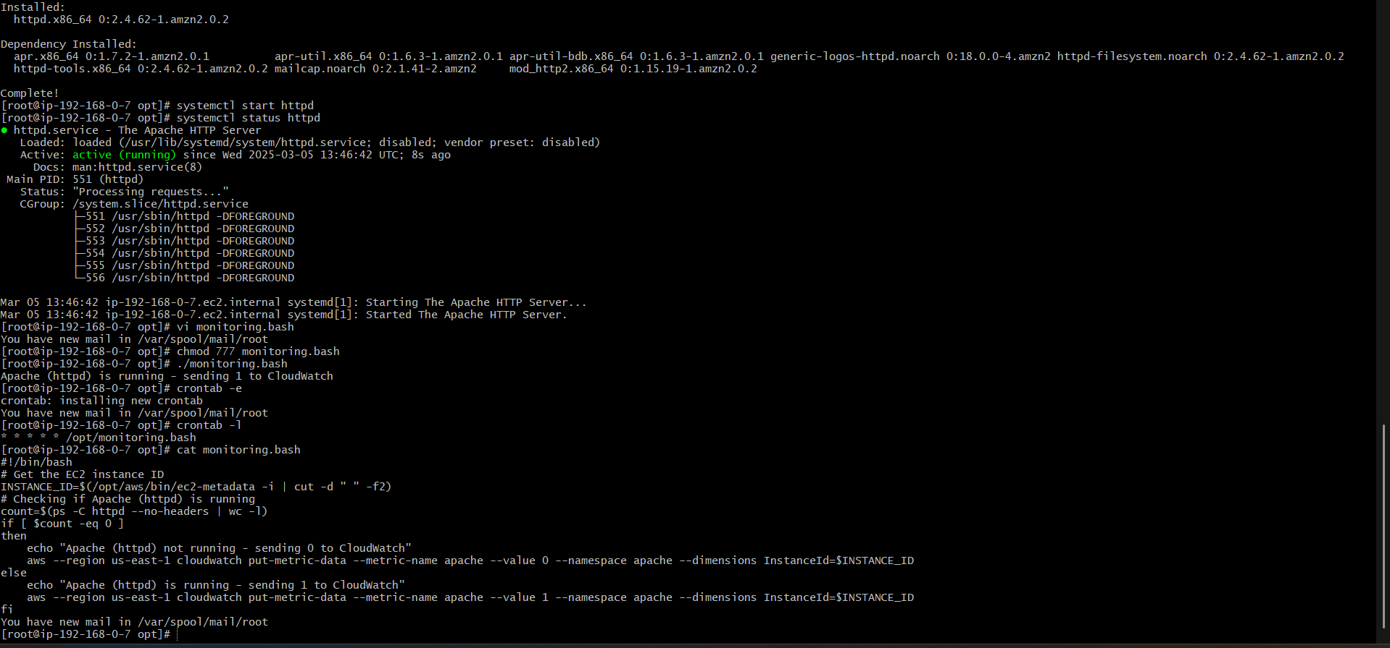

----- create one dashboard and check if it displays 1 in the dashboard as we mentioned in the script   
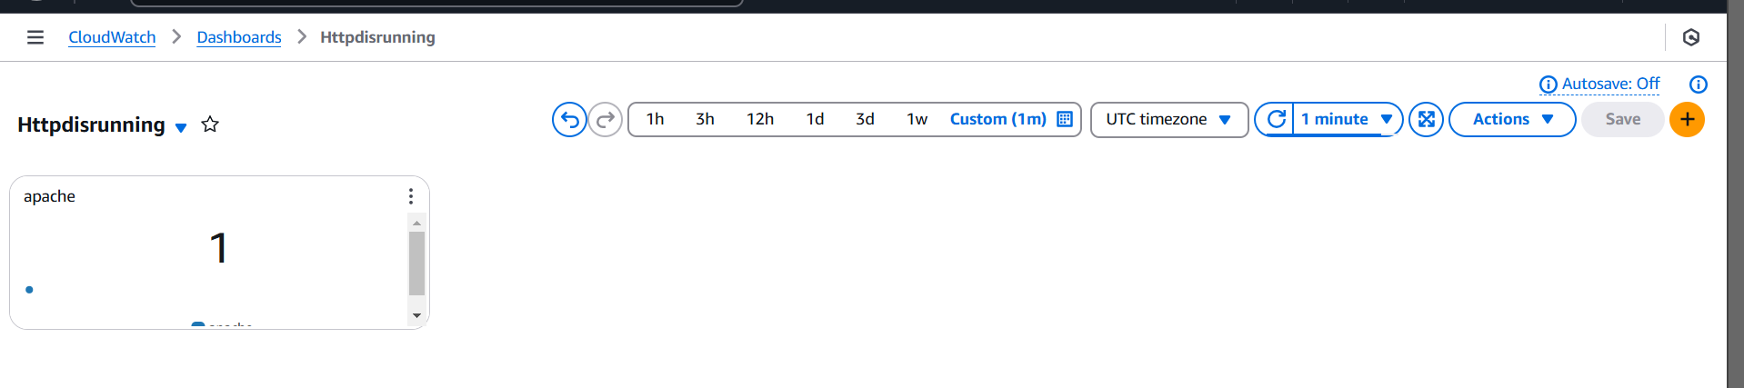

-------create another dashboard for cpu-ulilization and add by using instances ID

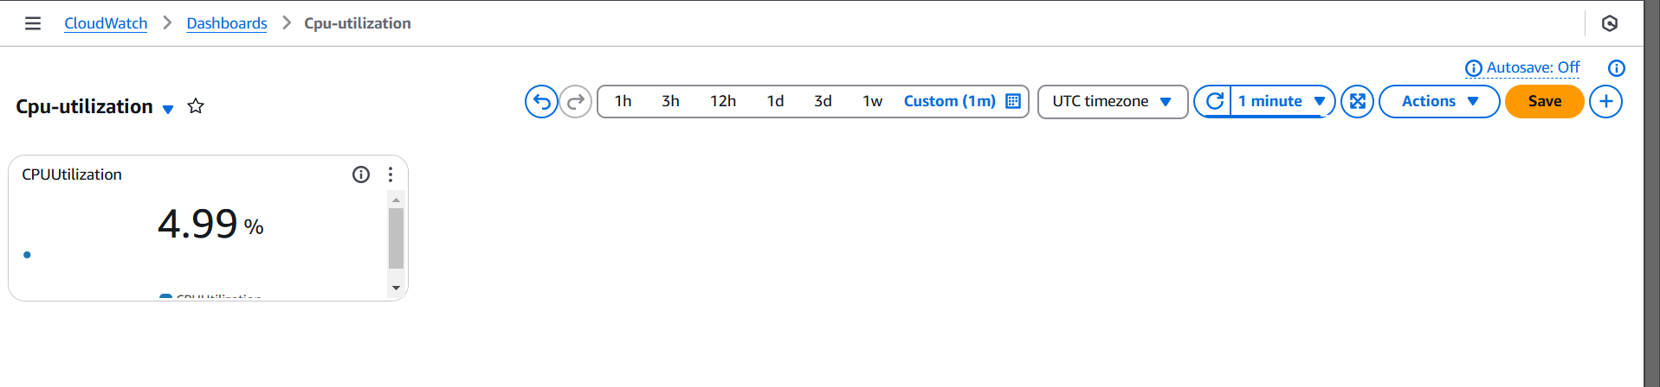

--------- we see both the dashboard are created

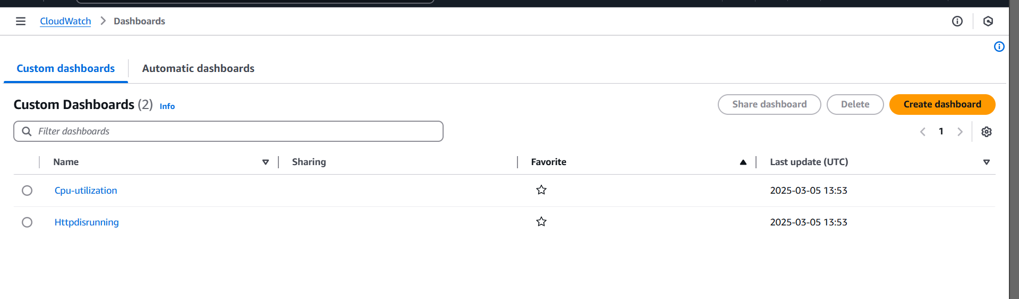

12) CPU utilizationis more than 70% then it should triggere Autoscaling and launch new instance.

---- create launch template and configure auto scaling group   
 ------ 2 new instances been launched , we see this in autoscaling --- activity history tab

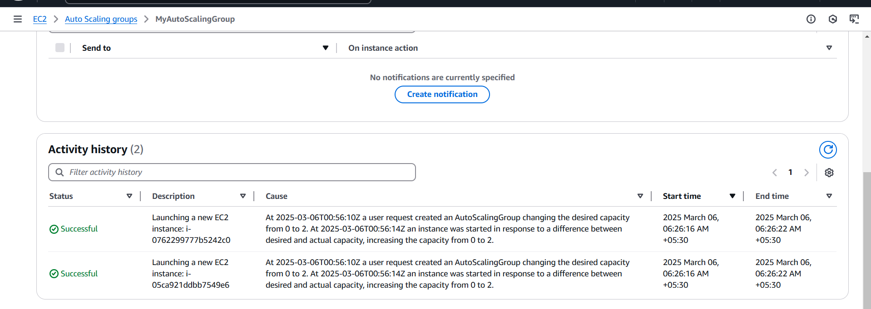

------ increase the load of cpu to 70% 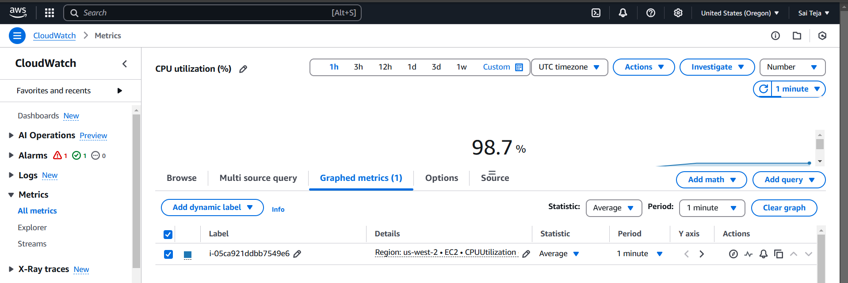  
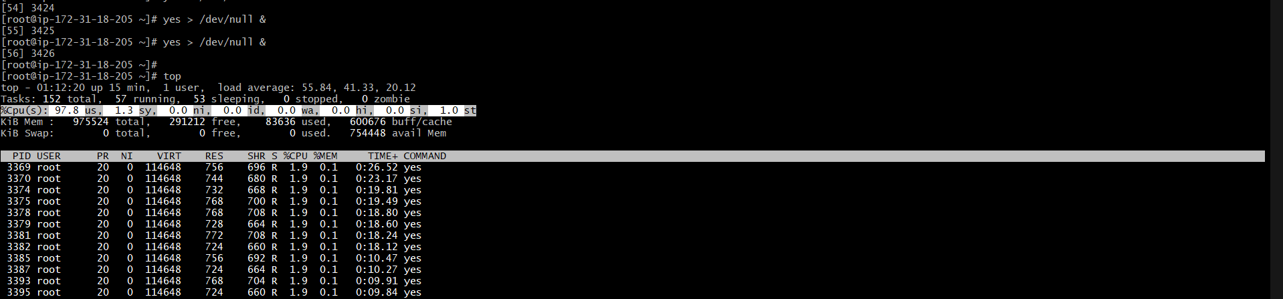

----- as cpu load is increased to 70% , it triggered Autoscaling and launch new instance.  
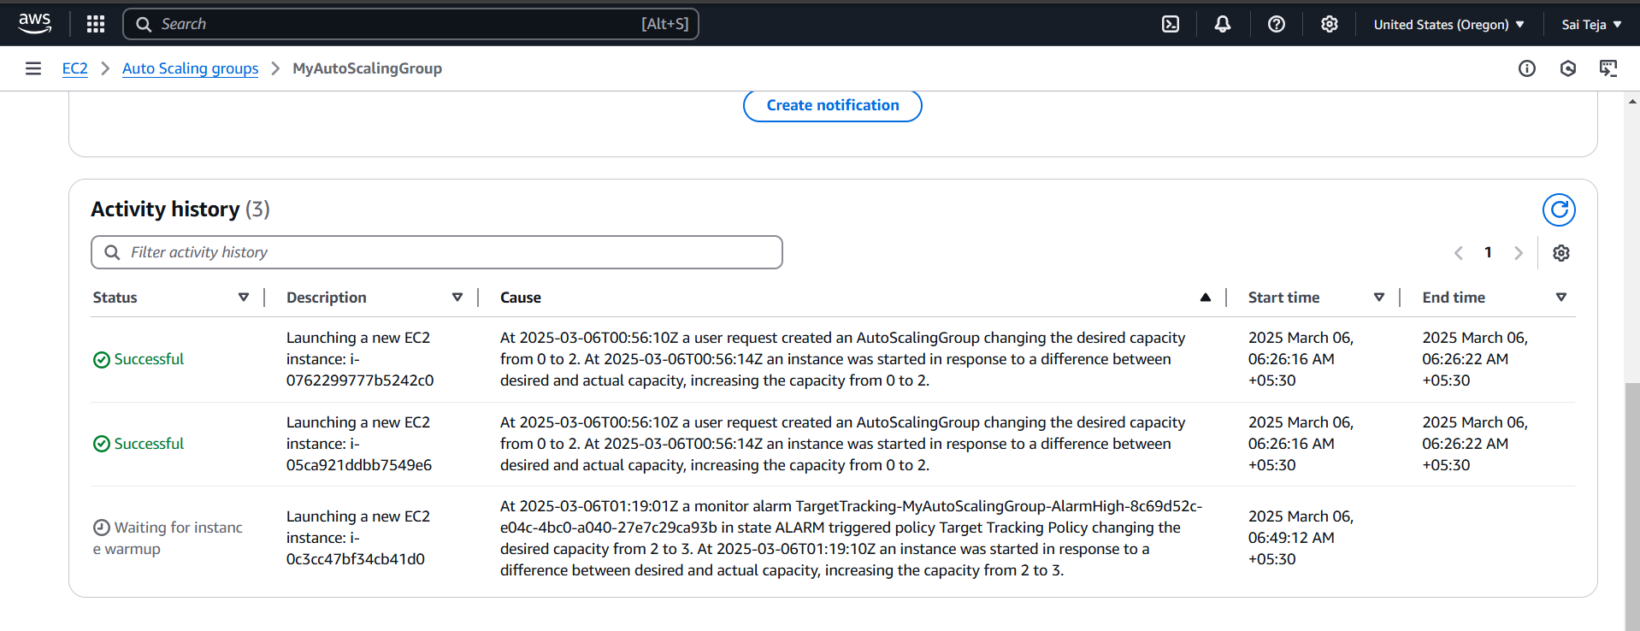

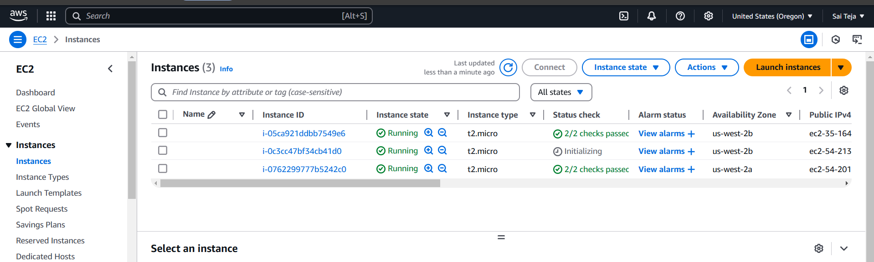

10) Store the vpc flow logs to cloudwtach group

---- create one log in cloudwatach group (My-log)  
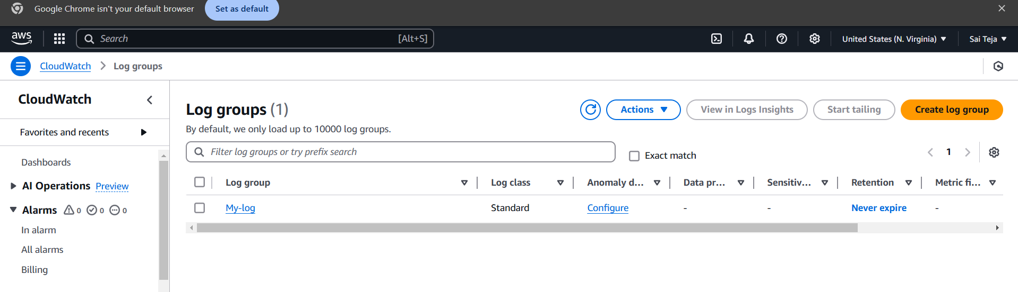

-------create one IAM role and attach policy

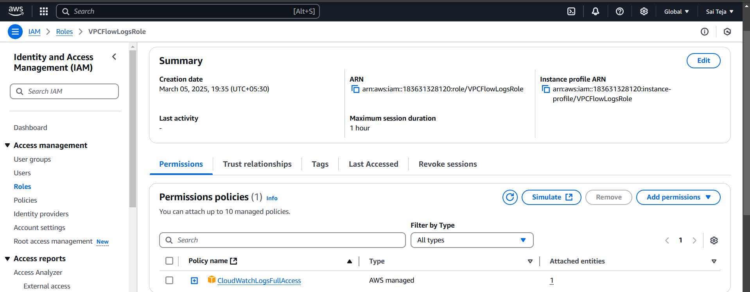

----- create vpc flowlog and attach cloudwatch group and IAM role

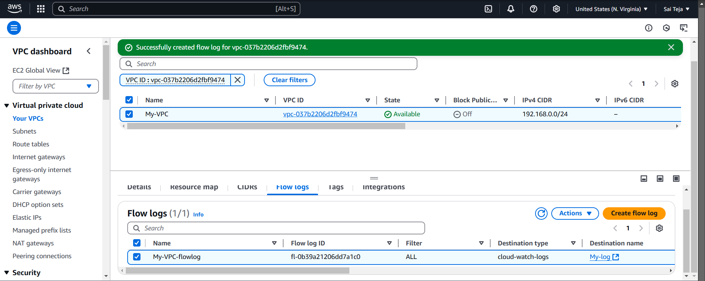

---- we can find the vpc flowlogs   
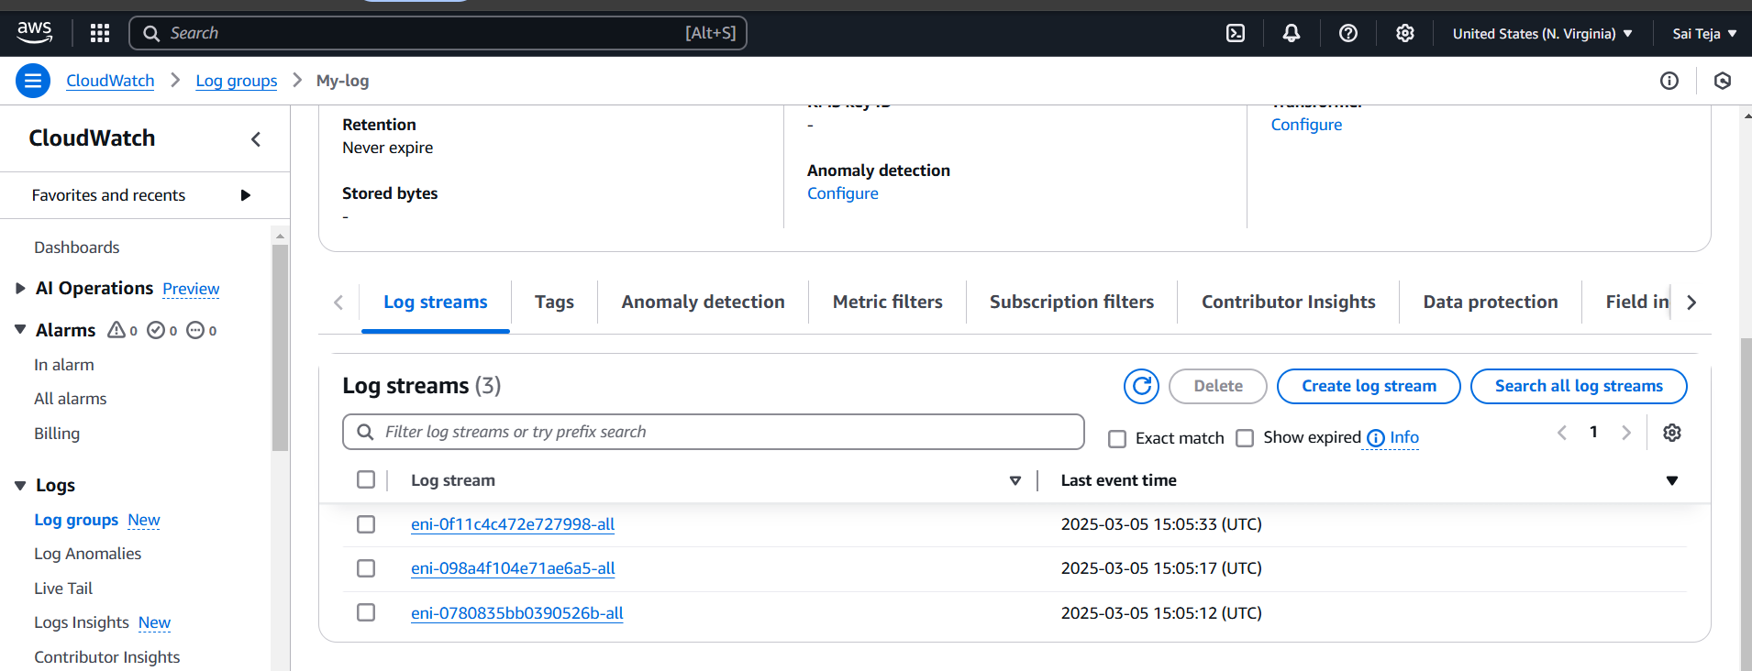  
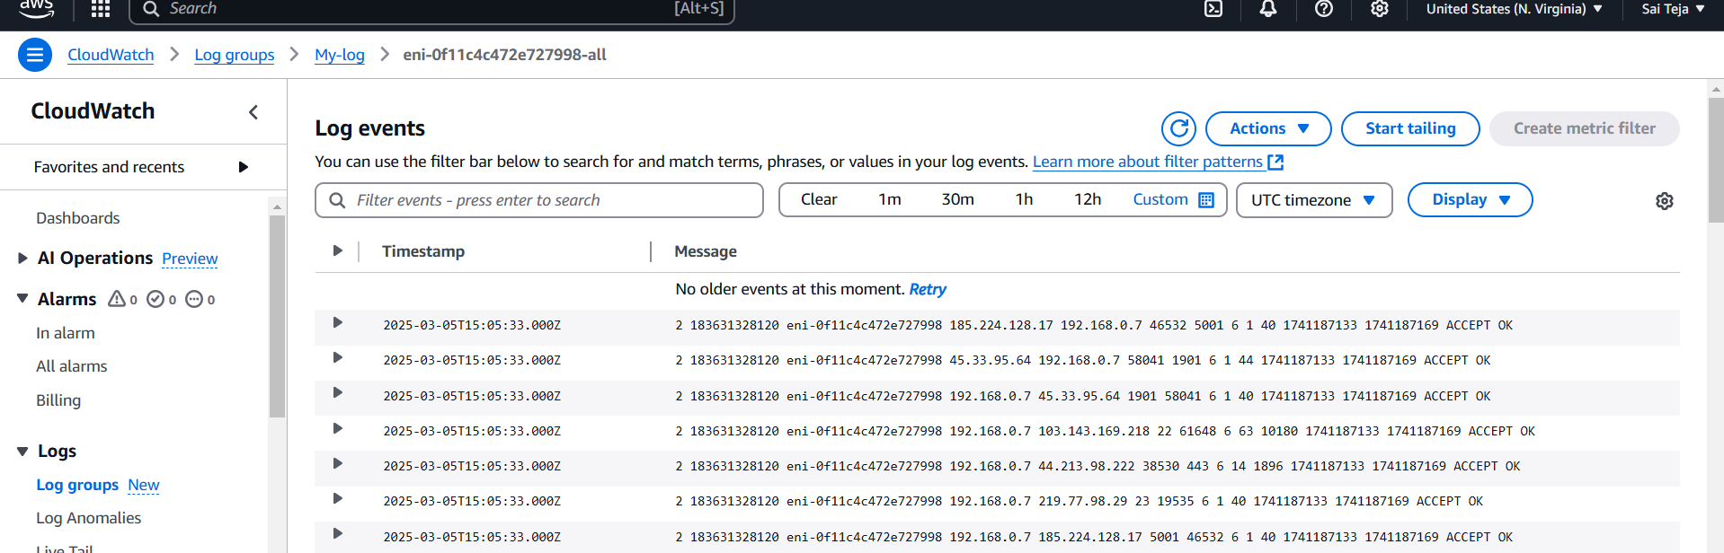

8) Create one application load balancer and attach the load balancer to both the ec2 instances.

---create the target group and attach to the sever 1

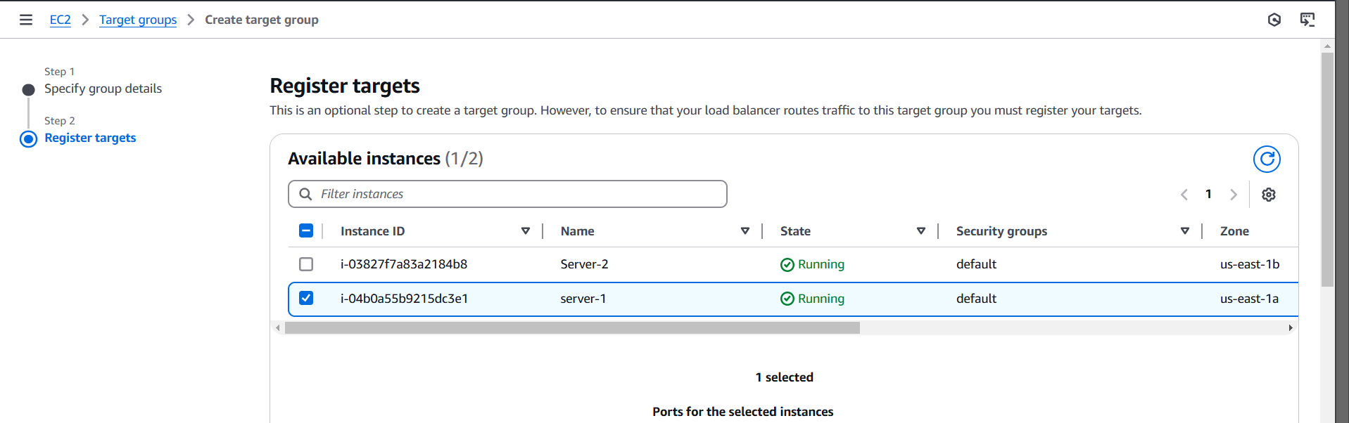

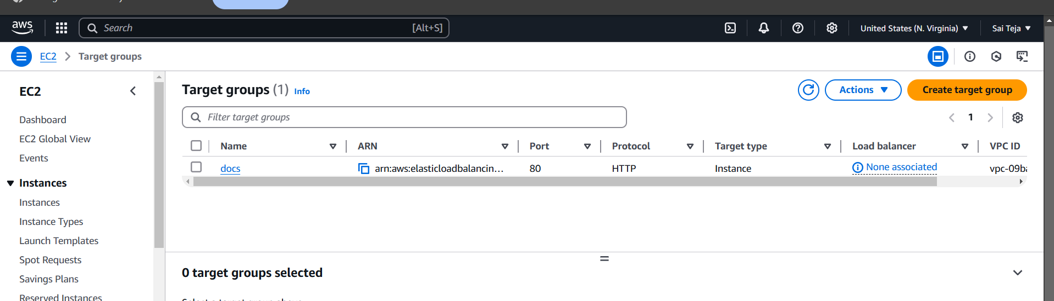

--- add the target group in the default while creating app loadbalancer and check for health status for attached ec2 instances (server 1)

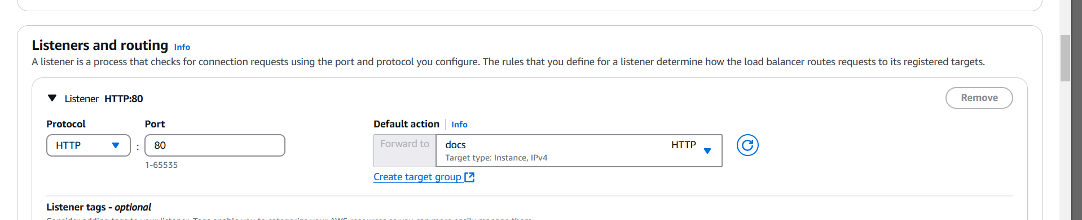

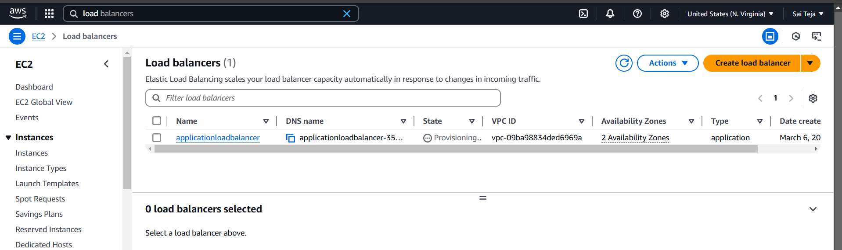

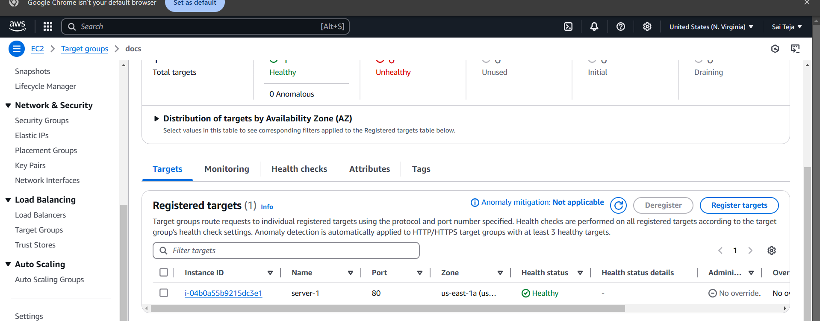

Copy the url of app loadbalancer and paste in the browser

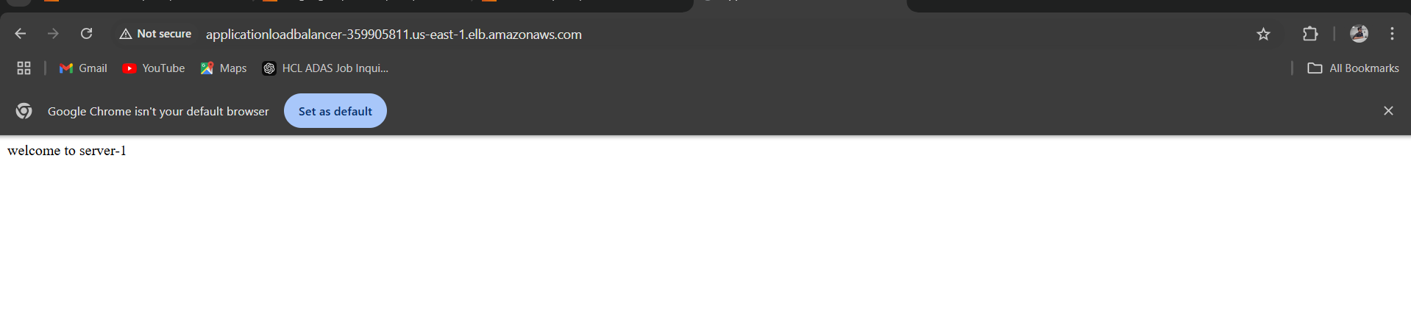

--- add rule that /docs using load balancer url with /docs I need to access for target grop docs

--- before that configure that in the server level

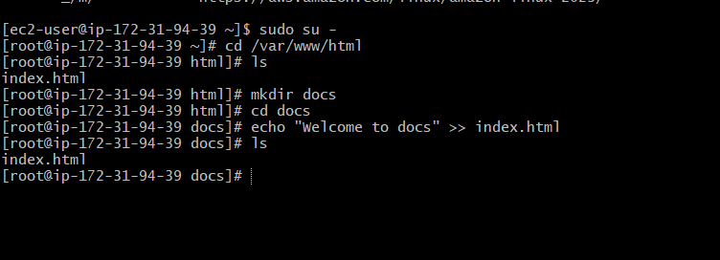

Go to load balancer – listener rule – click on rule – add rule – name(docs)- path - /docs\* -done

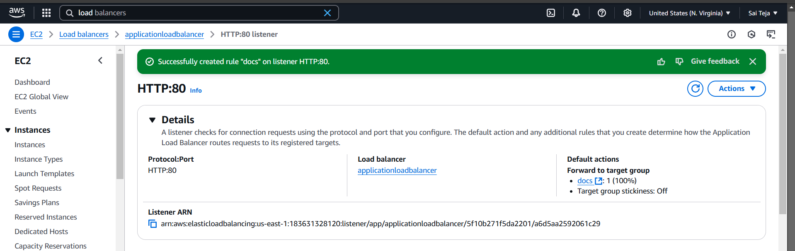

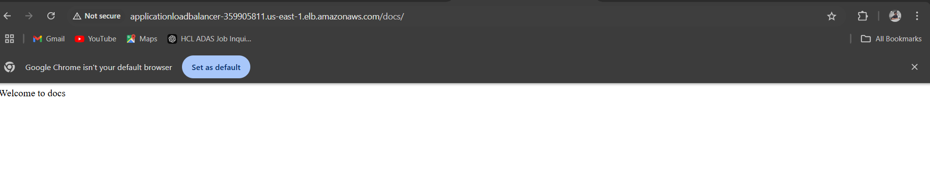

9) Store Application load balancer logs to s3.

---create one s3 bucket

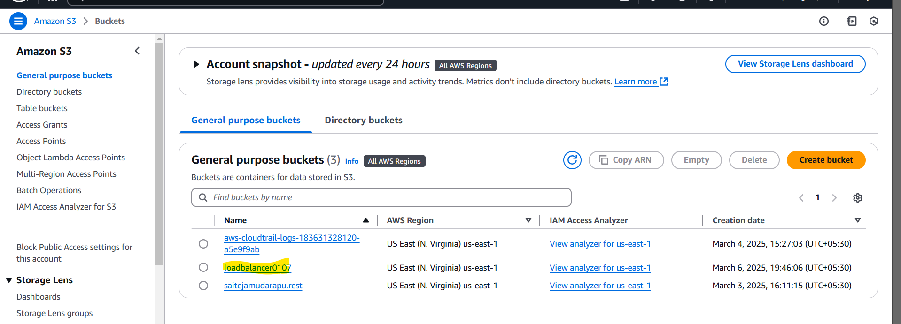

---- to go permission add policy in the bucket policy

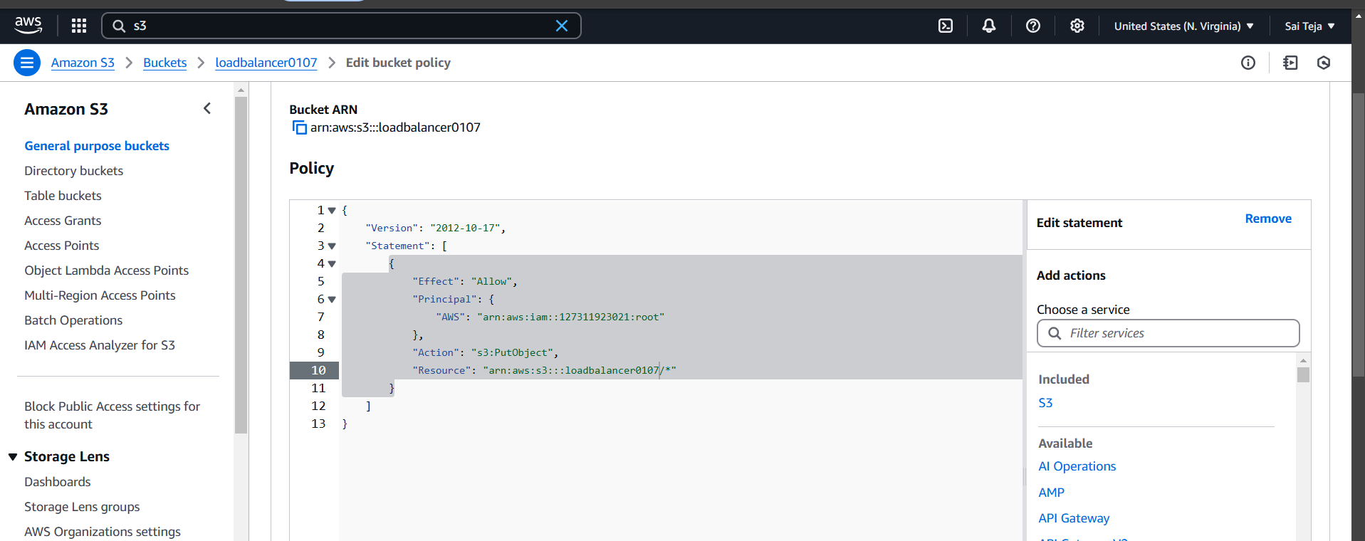

--- add s3 bucket to the apploadbalancer

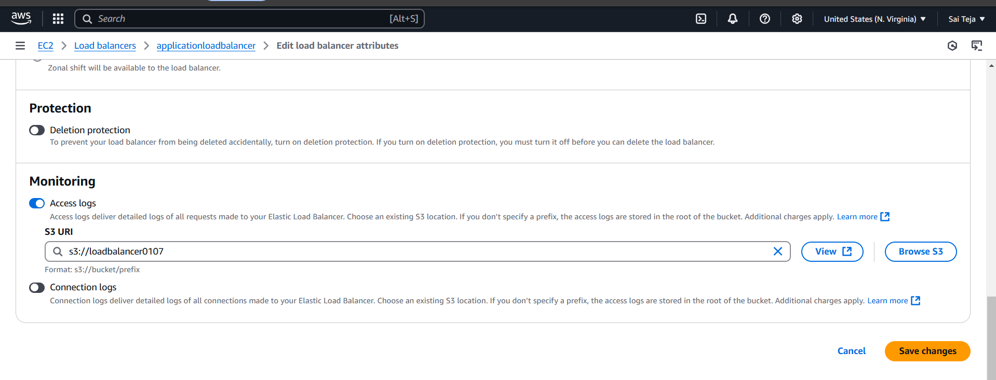

----go to s3 bucket and we can find log files

